Queue Simulation

Project - ECE 610

Filza Mazahir

20295951

fmazahir@uwaterloo.ca

Table of Contents

Note on Code 3

Question 1 – Generate Exponential Random Variable 3

Question 2 – Simulator for M/M/1, D/M/1 and M/G/1 Queue 5

Simulation Initialization (Input Variables) 5

Event Scheduler 6

Run Simulation function (and computing output variables) 10

Creating a Queue to run simulation and accessing output variables 11

System Stability 11

Question 3 – M/M/1, D/M/1, and M/G/1 – E[N] & PIDLE (0.35 ≤ ρ ≤ 0.95) 12

E[N] as a function of ρ 12

PIDLE as a function of ρ 13

Question 4 – M/M/1, D/M/1, and M/G/1 – E[N] & PIDLE (ρ = 1.5) 14

Question 5 – M/M/1 and D/M/1 – Comparison of E[N] and Ea[N] 15

Question 6 – M/M/1, D/M/1, and M/G/1 – Comparison of E[T] 16

Question 7 – Simulator for M/D/1/K Queue 17

Question 8 – M/D/1/K– PLOSS (0.4 ≤ ρ ≤ 3) 19

Question 9 – M/D/2 and M/D/1 (rate 2C) – E[N] (0.35 ≤ ρ ≤ 0.95) 20

# Note on Code

The queue simulation is coded in Python 3. The external libraries used for this project are numpy and matplotlib. The makefile submitted makes two assumptions:

1) It assumes that the Python libraries numpy and matplotlib are already installed on the server. If that is not the case, they can be installed using the requirements.txt file submitted.

2) It assumes that Python 3 is executed with the keyword python3, and executes the command python3 ECE610ProjectFilzaMazahir.py. If that is not the case and Python 3 on the server has the default keyword python, please use python ECE610ProjectFilzaMazahir.py to run the source code.

It takes around 18 minutes to run the complete code. An output.txt file which has the values used for the graphs in all questions is outputted after the code is run.

# Question 1 – Generate Exponential Random Variable

*Exponential Distribution:*

Probability Density Function $f\left(x\right)=\left\{\begin{aligned}μe^{-μx}, &x≥0 \\ 0, &x<0\end{aligned}\right.$

Cumulative Density Function $F\left(x\right)= \int_{-∞}^{x}{f\left(t\right)dt=\left\{\begin{aligned}1-e^{-μx}, &x≥0 \\ 0, &x<0\end{aligned}\right.}$

Let U be a uniform random variable, and X be an exponential random variable.

$$F\left(X\right)=U$$

$$X= F^{-1}(U)$$

$$1- e^{-μX} = U$$

$$e^{-μX} = 1-U$$

$$-μ= \ln{ (1-U)}$$

$$X= \frac{-1}{μ} \ln{(1-U)}$$

Let $U_{i}$ be uniformly distributed random variable from 0 to 1. Then to generate exponentially distributed random variable from the random uniform variables $U_{i}$:

$$X_{i}= F^{-1}{(U}_{i})$$

$$X_{i}= \frac{-1}{μ} \ln{(1- U_{i} )}$$

Since $U_{i}$ and $(1- U_{i})$ are both uniformly distributed random numbers between 0 and 1:

$$U_{i}=1- U_{i}$$

Therefore:

$$X_{i}= \frac{-1}{μ} \ln{U_{i}}$$

Using the equation, the following Python code was written to generate an exponential random variable. Note that the variable mu in the code is for the parameter μ in the equation.

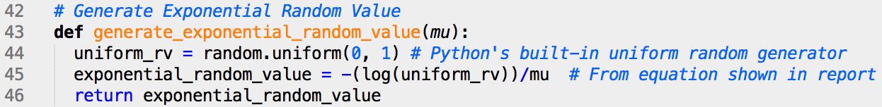

To generate 1000 exponential random variables:

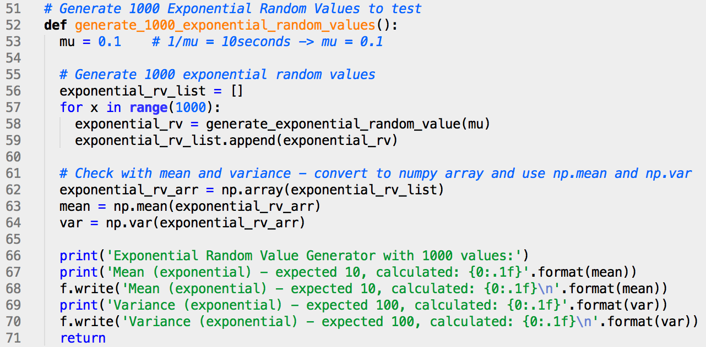

The expected values for the above code are mean of 10 and variance of 100. Running the above code gave mean of 10.4 and variance of 100.7, which is very close to the expected values.

# Question 2 – Simulator for M/M/1, D/M/1 and M/G/1 Queue

The simulator is built using a class Simulation which is initialized in the beginning with all the parameters needed to run the simulation. There are two main functions used for the simulation, first is create_event_scheduler(), which creates a double ended queue called Event_Scheduler consisting of observation, arrival and departure events. Second is run_simulation()which goes through the list of events in theEvent_Scheduler, dequeues events from the beginning, and then updates the system metrics (Nt - number of packets in the system) accordingly.

## Simulation Initialization (Input Variables)

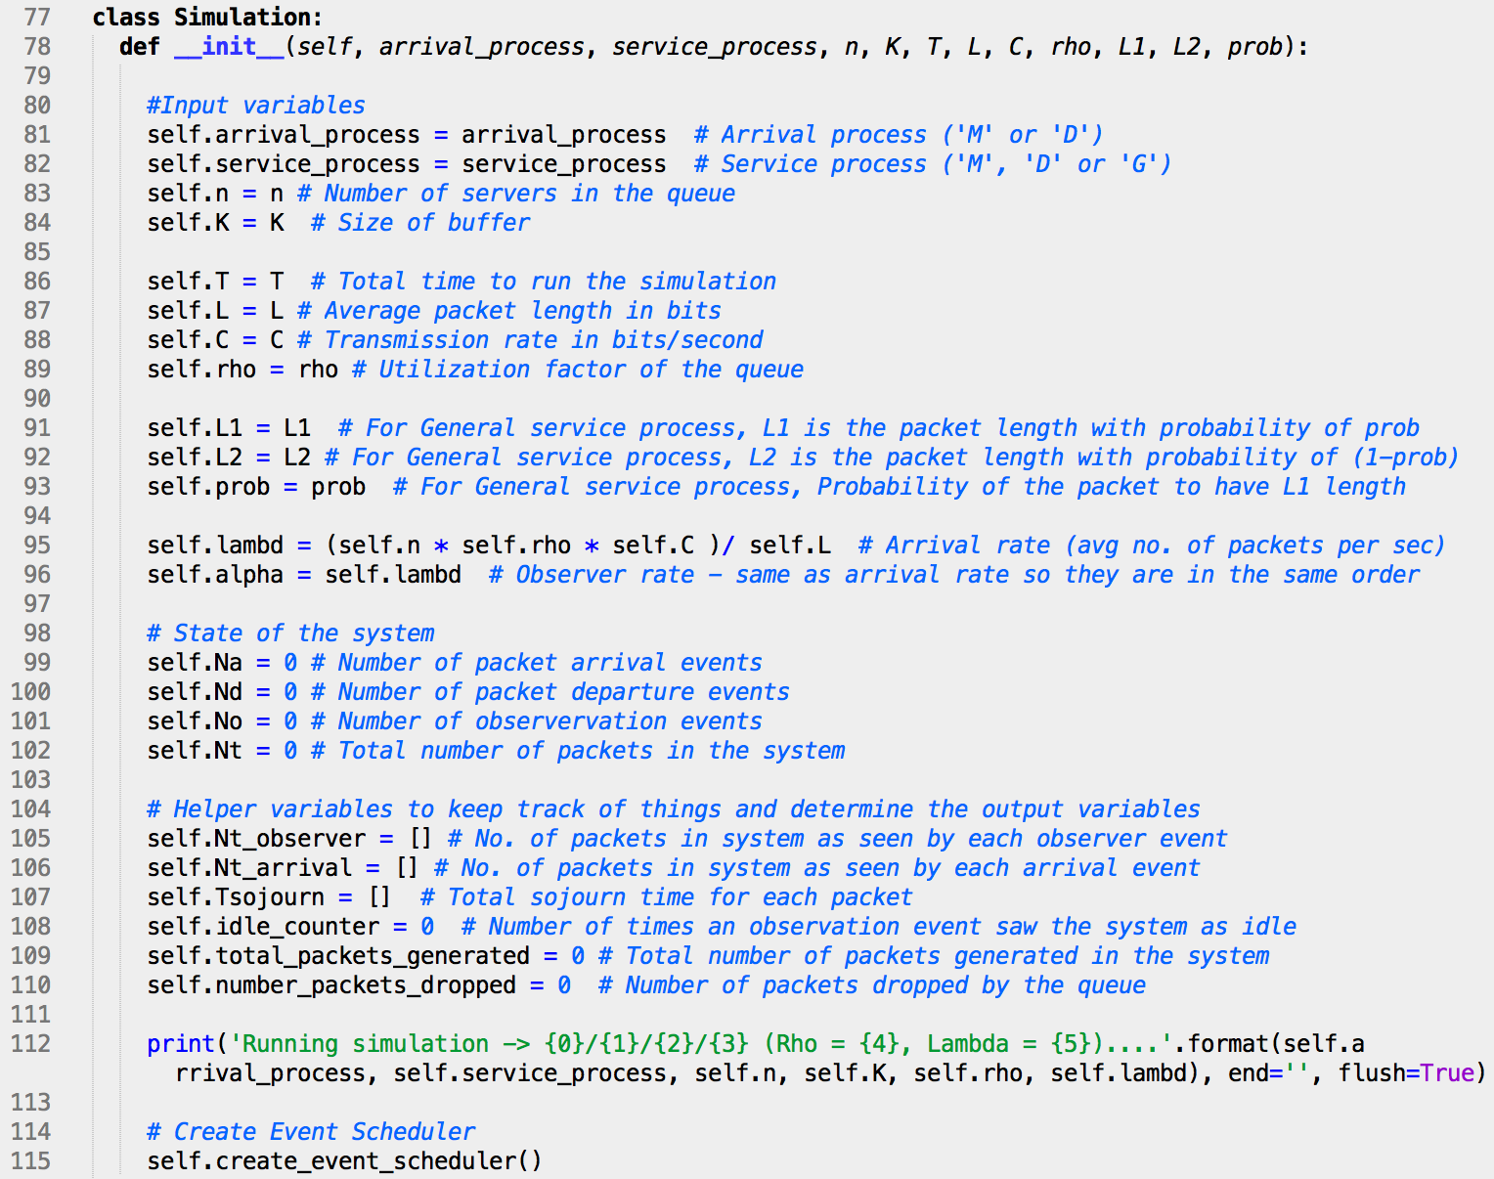

The simulator is built using a class Simulation as shown in the code above. When the simulation is initialized in the beginning, it gets all of its parameters such as arrival_process, service_process, n, K, T, L, C, rho, L1, L2, prob.

The variables for the type of queue are given as follows: arrival_process and service_process are specified by ‘M’, ‘G’, or ‘D’ for Poisson, General or Deterministic distribution respectively. n is for the number of servers in the queue, and K is the size of the buffer given in number of packets.

Other variables provided for the initialization are as follows: T is the total time for the simulation to run, L is the average length of packet in bits, C is the transmission rate of packet in bits/second, and rho is the utilization factor of the queue given by $= {Lλ}/{nC}$. The variables L1, L2 and prob are also provided for the General distribution where the packet length has a bipolar distribution, and is determined as L1 with probability of prob, and L2 with probability of 1 – prob. For queues that do not have a General service distribution, a value of 0 can be input for L1, L2 and prob as they do not affect the code otherwise.

Once these variables are initialized, lambd, which is the arrival rate (average number of packets generated per second) is calculated using $λ= { nC}/L$. The variable alpha, which is the observation rate, is then set equal to lambd, as both the observation rate and arrival rate are supposed to be of the same order.

The state of the system is defined as the number of packets in the system, given by the variable Nt. Other variables to keep track of this are Na (number of observation events), Nd (number of departure events), and No (number of observation events). These are all initialized to 0, and only get incremented when an event occurs.

Some helper variables are also introduced in the Simulation class, which aid in calculating the output variables. Nt_observer is a list that has the number of packets in the system as seen by all observer events. Similarly, Nt_arrival is a list that has the number of packets in the system as seen by all arrival events. The variable Tsojourn is a list that stores the total sojourn time of all packets in the system. The variable idle_counter is the number of times that an observer event sees the system as idle, and total_packets_generated keeps track of the total number of packets generated in the system. The variable number_packets_dropped keeps track of any packets lost because of buffer being full, and is only incremented for the M/D/1/K queue. The variables idle_counter, total_packets_generated, and number_packets_dropped are initialized to 0 as that is the case initially.

## Event Scheduler

The Event Scheduler is created upon initialization in the create_event_scheduler() function. Event_Scheduler is a double ended queue which consists of events where each event is in the form of a two variable tuple (event_type, event_time). The event_type is given in the form of ‘O’, ‘A’ and ‘D’ for Observer event, Arrival event and Departure event respectively, and event_time is the time when the particular event happens.

*Helper functions:* Two helper functions are used by the create_event_scheduler() function: generate_arrival_time() and generate_packet_length().

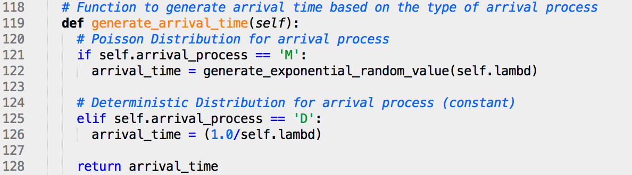

The function generate_arrival_time() shown above checks the class variable arrival_process. If it is ‘M’ for Poisson, then it uses the generate_exponential_random_value() function created in Question 1 to generate arrival time. If the arrival_process is ‘D’ for Deterministic, then arrival time is calculated as the constant of 1/λ.

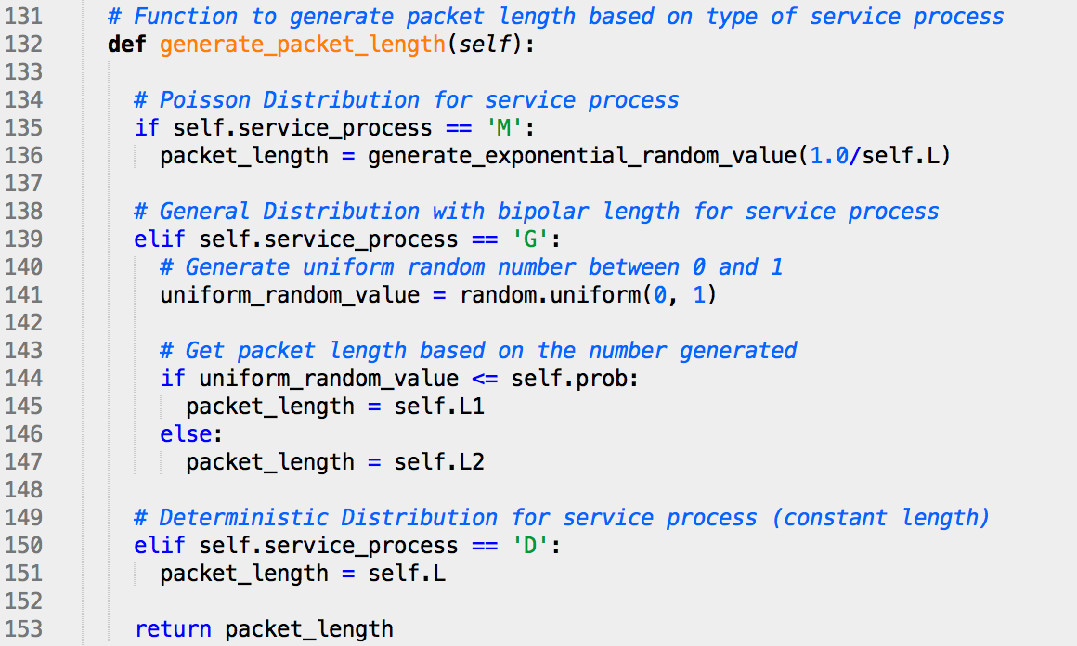

The service time of a process is equal to $L/C$. Since the transmission rate C is constant for each packet, the packet length L is what changes based on type of service process. Therefore, the function generate_packet_length() shown in the code above checks for the class variable service_process. If it is ‘M’ for Poisson, then it uses generate_exponential_random_value() function from Question 1 to generate exponential random length with the parameter 1/L as the mean. If the service process is ‘G’ for General, then it computes a uniform random value between 0 and 1 to determine the length. Since the probability of the packet to have L1 as its length is given by the variable prob (0.2 as an example), if the uniform random number generated is less than or equal to prob (as in between 0 and 0.2 in the example), the length is L1. If the number is greater, the length is L2. If the service process is ‘D’ for Deterministic, then packet length is calculated as the constant of L.

*Create Event Scheduler Function:*

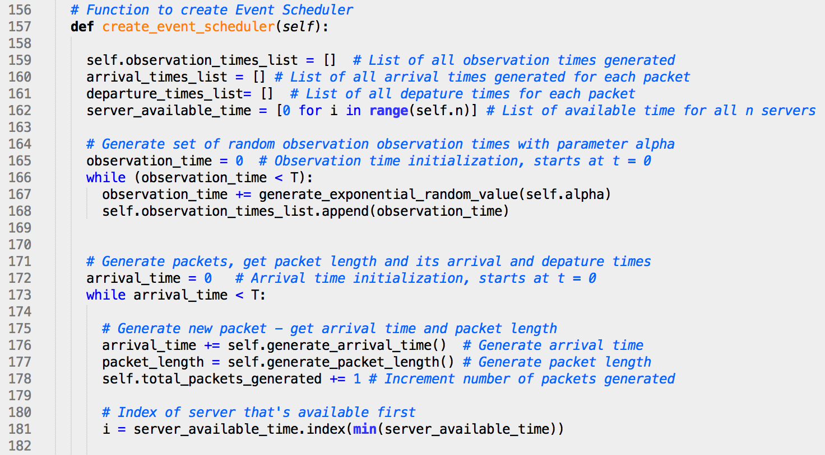



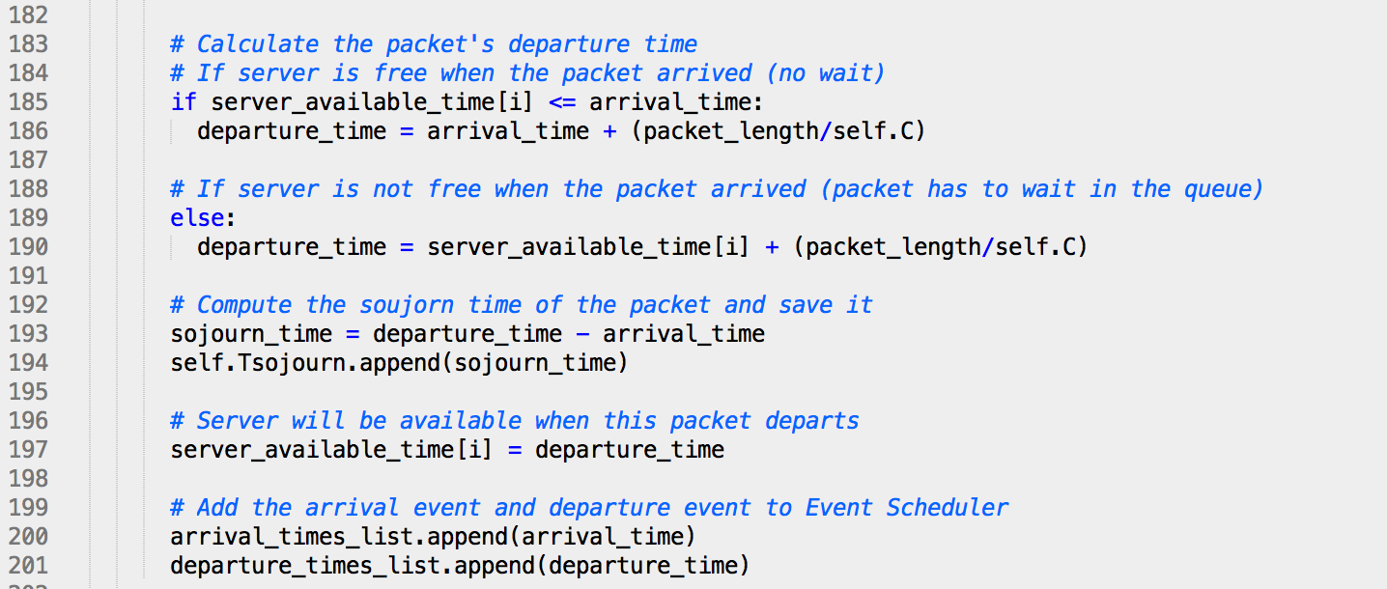

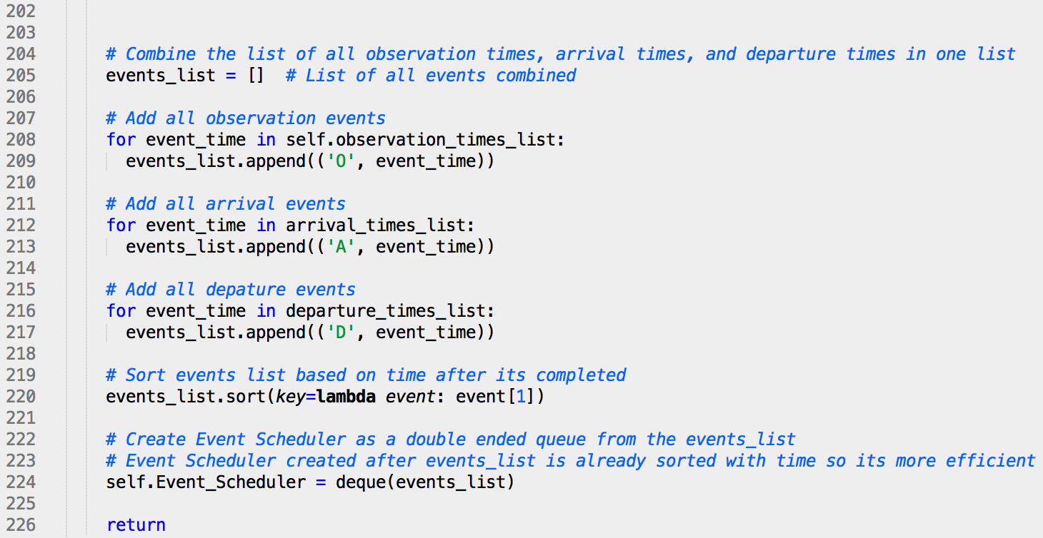



The create_event_scheduler() function shown in the previous page has three lists for each type of event, observation_times_list, arrival_times_list, and departure_times_list. This is where the event time for each observation, arrival and departure is added respectively. The server_available_time is a list of size n (either 1 or 2), and is initialized as 0. It stores the times that each server will become available.

First, a set of observation times is generated and stored in the observation_times_list. Then a new packet’s arrival time and packet length is generated, and it is checked which server will become available first to service this packet. Note that in the case of 1 server, server_available_time is of size 1 only, and its minimum is its only element. Then based on the server_available_time it is checked if the server is free to service this packet right away or will this packet have to wait. If server is free, then departure time is calculated as arrival_time of the packet plus transmission time of packet_length/C. If server is not free, then departure time is calculated as server_available_time[i] (the time server becomes available) plus transmission time of packet_length/C. The server_available_time for the server used is then updated to be the departure time of this packet, as that will be the next time this server will be available to serve a packet. The sojourn time (total time) of the packet is then calculated and appended in the T_sojourn list, and the packet’s arrival and departure times are added in the arrival_times_list and departure_times_list respectively.

Once all the packets are generated with its arrival and departure times computed, the function goes through each of the three lists, observation_times_list, departure_times_list, and arrival_times_list, and adds the events to an events_list in the form of tuples (event_type, event_time), where event_type is ‘O’, ‘A’, or ‘D’, and event_time is the corresponding event time.

After that, the events_list is sorted with time using Python’s sort() function so the FIFO method could be applied by transmitting packets from the beginning of the list. Python’s sort() function uses a Timsort algorithm and is quite efficient. A double ended queue called Event_Scheduler is then created from the events_list. Note that the reason for a separate events_list and Event_Scheduler is that events_list uses the data structure of a Python list, which is faster to sort, and Event_Scheduler is a double ended queue which is more efficient when dequeueing the event from the beginning of the list.

## Run Simulation function (and computing output variables)

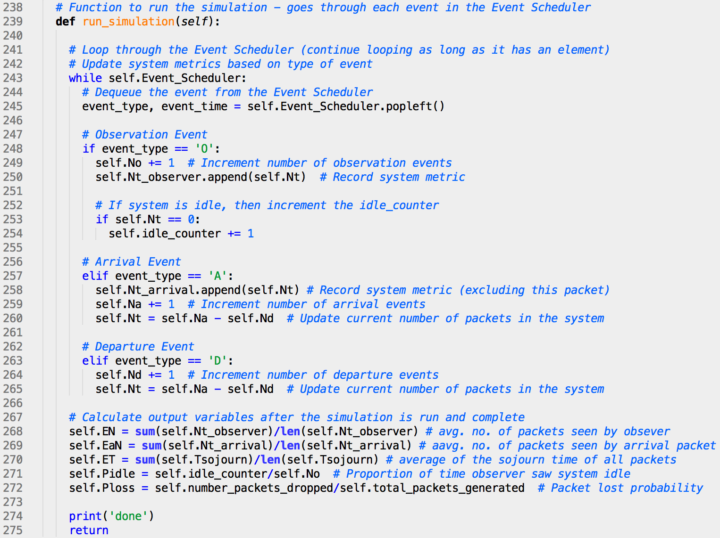

This function run_simulation() shown above goes through the Event_Scheduler, and dequeues one event at a time. Based on the type of event (observer, arrival, or departure) dequeued, it updates the system metrics (Nt - number of packets in the system) accordingly. The observation and arrival events also keep track of the variable Nt in Nt_observer and Nt_arrival respectively. In addition, at each observation event the function also checks whether the system is idle or not, and if it is, it increments the idle_counter accordingly.

After going through the whole Event_Scheduler, the output variables are calculated. The variable EN is for E[N] (average number of packets in the system as seen by an observer), and is calculated by taking the average of the Nt_observer list. The variable EaN is for Ea[N] (average number of packets in the system as seen by an arrival packet), and is calculated by taking the average of the Nt_arrival list. The variable ET is for E[T] (average sojourn time), and is calculated by taking the average of the T_sojourn list. PIDLE is denoted by the variable Pidle, and is calculated as the number of times the system was observed to be idle divided by the total number of observation events. PLOSS is denoted by the variable Ploss, and is calculated as the number of packets dropped in the system divided by the total number of packets generated. Note that since the functionality of M/D/1/K queue is not added to the code yet until Question 7, Ploss is always 0 since number_packets_dropped was initialized to 0 and remains the same.

## Creating a Queue to run simulation and accessing output variables



The above code is used to create a queue for M/M/1 using the class Simulation, and then the simulation is run to compute the output variables. It should be noted that inf passed for the parameter K is for floating point positive infinity in Python. The output variables of the system can then be accessed as follows.

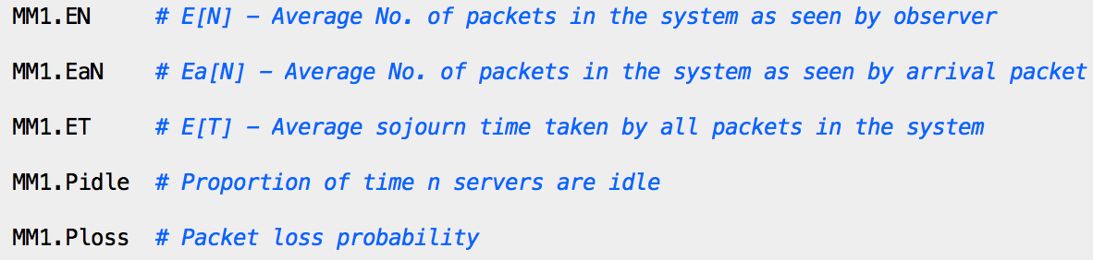

## System Stability

The value of T (total time to run the simulation) was checked after building the simulation to ensure that it gives a stable system. This was done by initially choosing the value of T to be 10,000 seconds, and then simulating three queues, one each for M/M/1, D/M/1, and M/G/1. The same three queues were then simulated again for double the amount of T (20,000 seconds). The output variable of E[N] (average number of packets in system) was compared for the two times with their respective queues, and as seen in the output block below, it was seen that the values were always within 5% of each other.

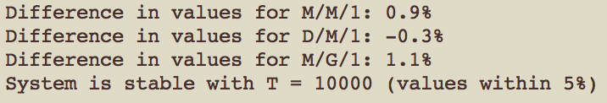

# Question 3 – M/M/1, D/M/1, and M/G/1 – E[N] & PIDLE (0.35 ≤ ρ ≤ 0.95)

For this question, the simulator was run inside a for loop such that the values of ρ went from 0.35 to 0.95 with a step size of 0.05. The values of E[N] and PIDLE were saved in a list, which was then used to plot the following figures.

## E[N] as a function of ρ

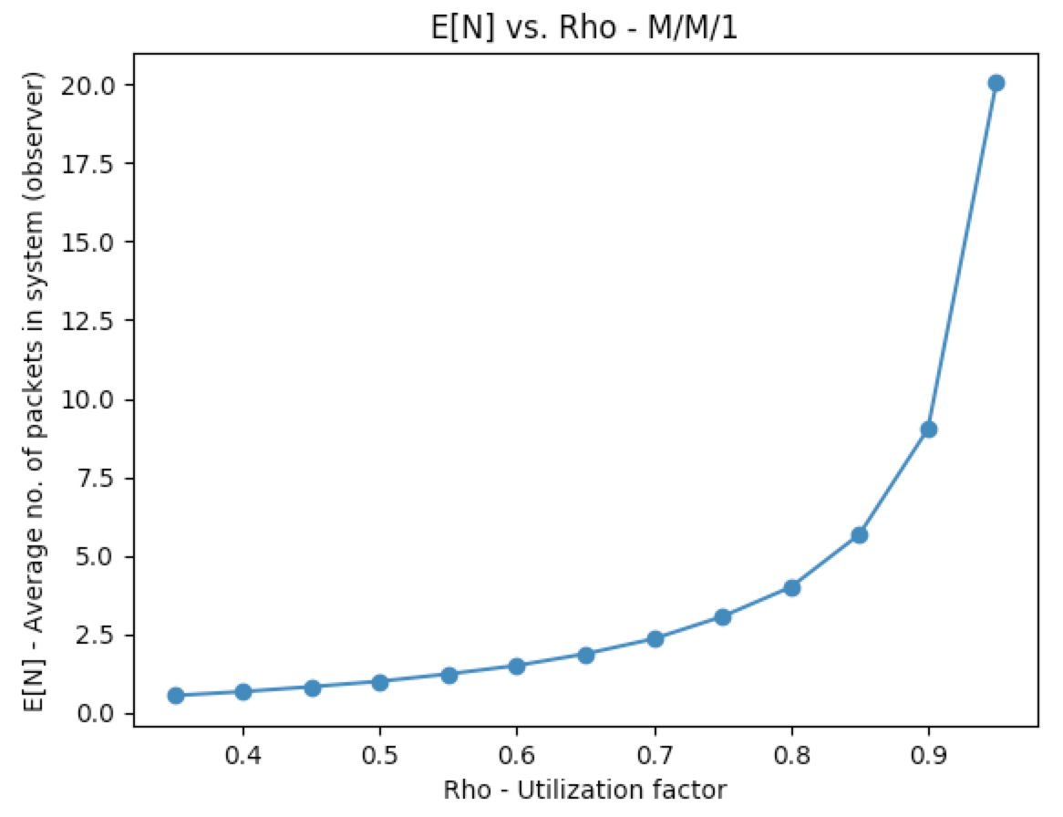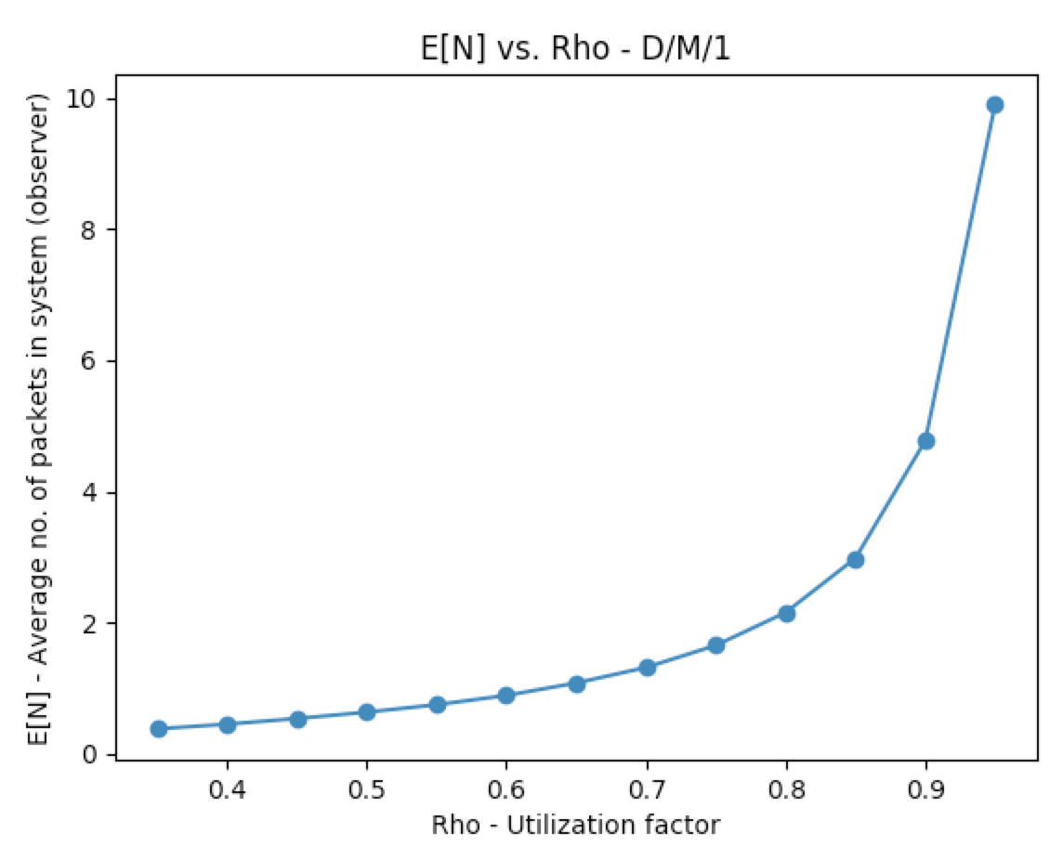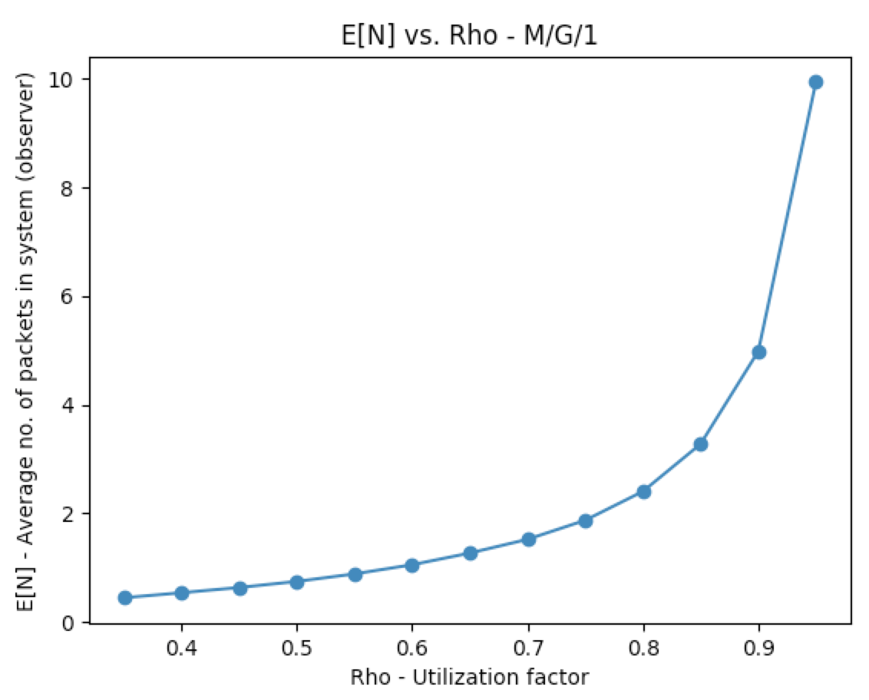

**Fig 1:** E[N] vs. Rho (M/M/1) **Fig 2:** E[N] vs. Rho (D/M/1) **Fig 3:** E[N] vs. Rho (M/G/1)

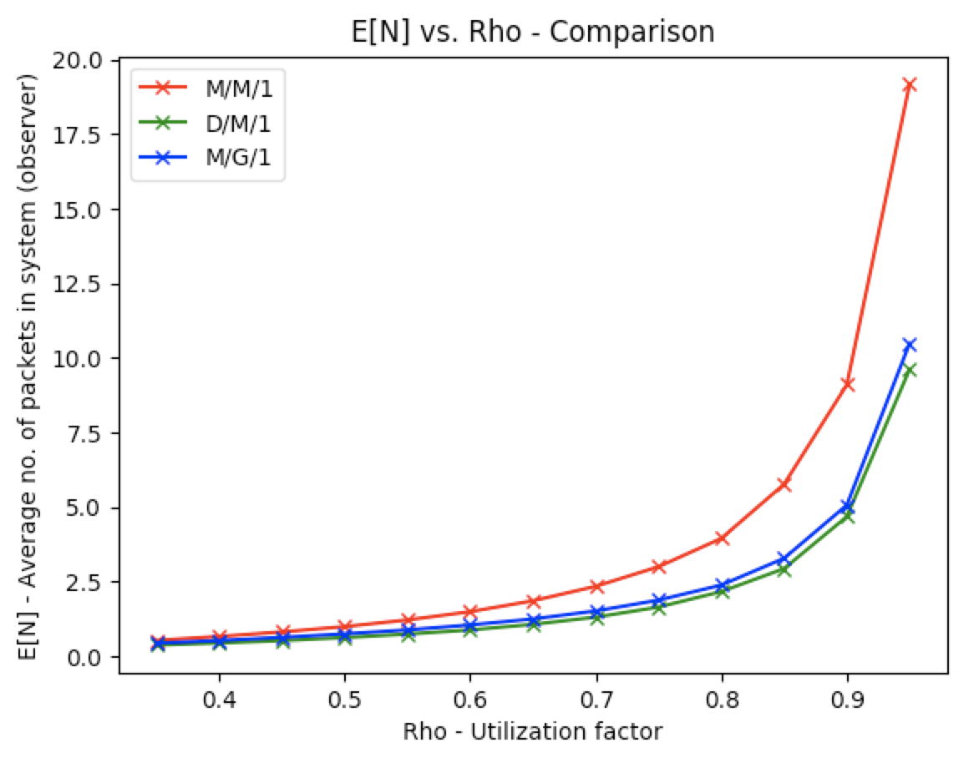

**Fig 4:** E[N] vs. Rho for M/M/1, D/M/1, and M/G/1

Figures 1, 2, and 3 show E[N] as a function of ρ for M/M/1, D/M/1, and M/G/1 respectively. All three of these queues have an exponential relationship between E[N] and ρ. As ρ increases, the average number of packets in the system increases exponentially.

Comparing the three queues in Figure 4 shows that M/M/1 has the highest average number of packets in the system, as compared to D/M/1 and M/G/1. This is because in M/M/1, the arrival and service process are both Poisson, so there is a chance of lots of packets coming in quickly and building up in the queue, hence having a greater delay. On the other hand, for D/M/1, the arrival rate is constant so the queue does not build up that much, and for M/G/1, the service rate is bipolar and not exponential like in M/M/1.

## PIDLE as a function of ρ

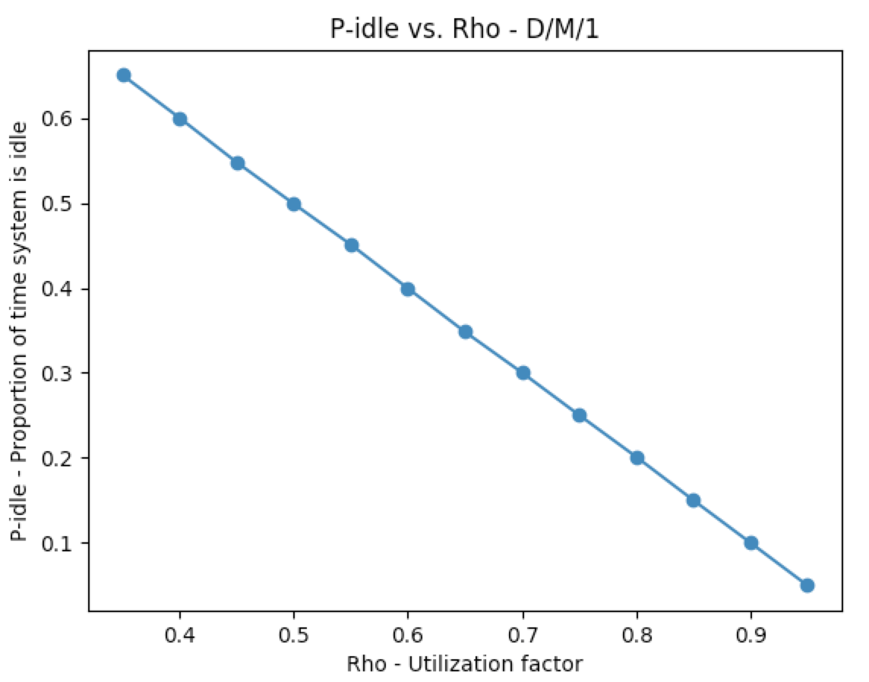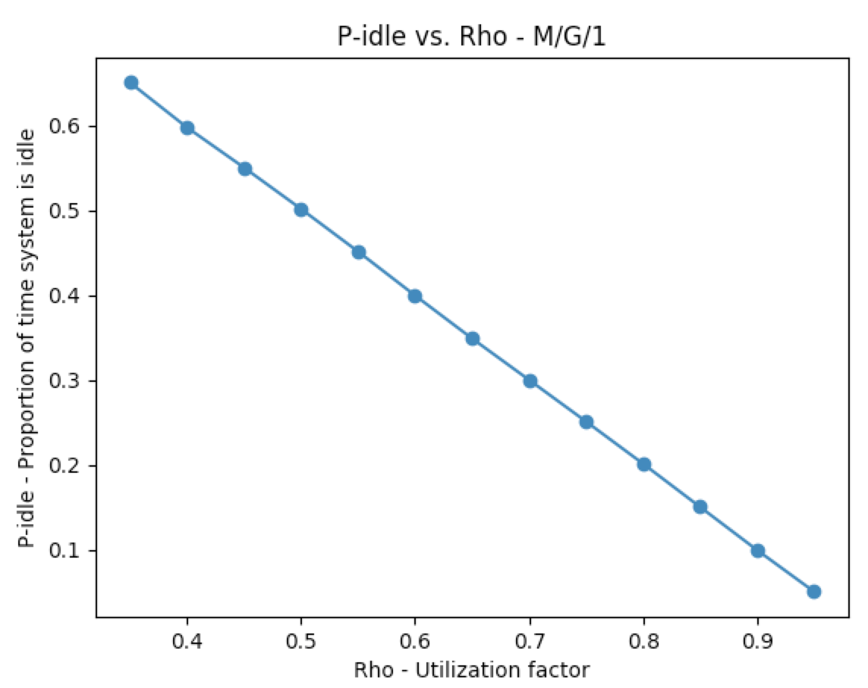

**Fig 5:** PIDLE vs. Rho (M/M/1) **Fig 6:** PIDLE vs. Rho (D/M/1) **Fig 7:** PIDLE vs. Rho (M/G/1)

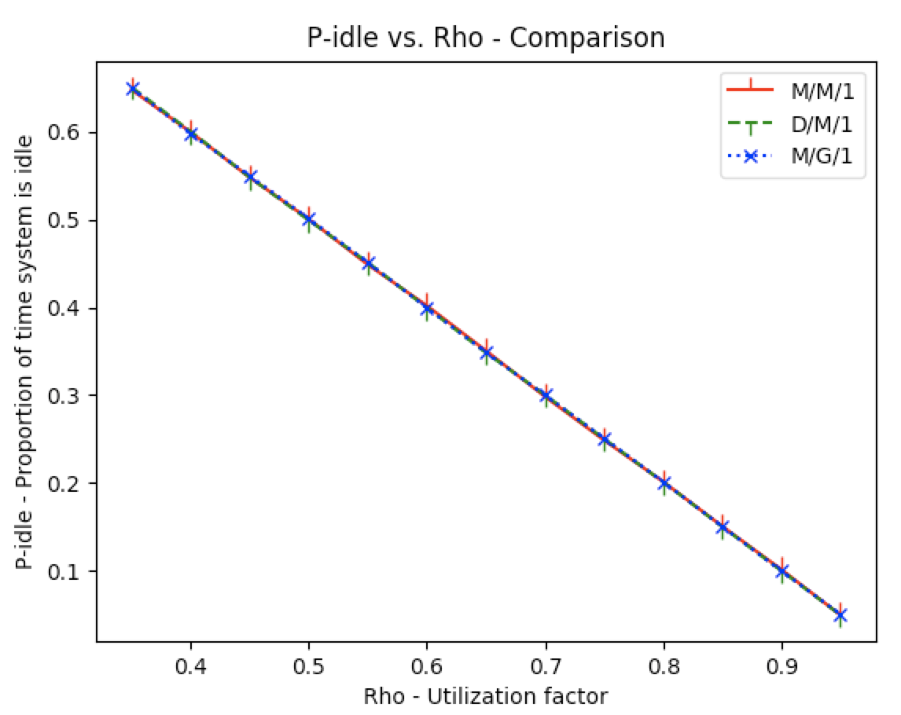

**Fig 8:** PIDLE vs. Rho for M/M/1, D/M/1, and M/G/1

Figures 5, 6, and 7 show PIDLE as a function of ρ for M/M/1, D/M/1, and M/G/1 respectively. Each of these figures show an inverse linear relationship between PIDLE and ρ. As ρ increases, PIDLE decreases linearly. Comparing the three queues in Figure 8 show that the proportion of time system is idle is the exact same for all three of these queues, showing that PIDLE is independent of the type of queue simulated. This is because PIDLE depends solely on the utilization factor of the queue, which is the ratio of the arrival rate to service rate. As the utilization factor increases, that is, the arrival rate of the processes become higher as compared to the service rate, there are more packets in the queue, hence less time for the server to be idle.

# Question 4 – M/M/1, D/M/1, and M/G/1 – E[N] & PIDLE (ρ = 1.5)

For this question, the queue M/M/1 was simulated at ρ = 1.5, and E[N] and PIDLE were computed for this simulation, as shown in the output block below.



These numbers seem to follow the pattern seen in figure 1 and 5. E[N] grew exponentially from 18.1 at ρ = 0.95 to 250612.6 at ρ = 1.5. PIDLE at ρ = 1.5 is 0, which means the system is never idle, which is expected as ρ = 1.5 means that the utilization factor of the queue is surpassed (that is, the arrival rate is 1.5 times the service rate), so PIDLE will always be 0.

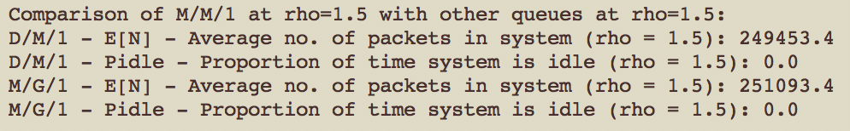

In order to compare E[N] and PIDLE of M/M/1 with other queues, D/M/1, and M/G/1 were also simulated at ρ = 1.5. As seen in the output block above, it was found that the average number of packets in the system at ρ = 1.5 were very similar for all three queues, and were in the same order. All three of these queues had the expected PIDLE of 0.



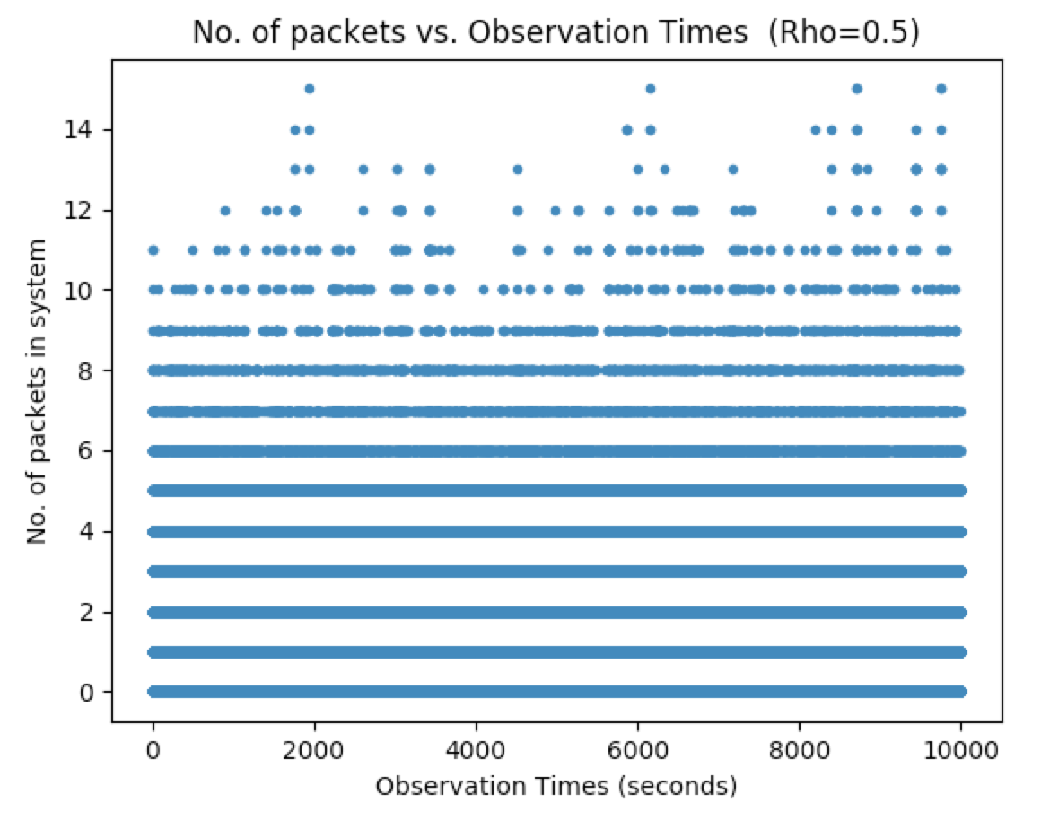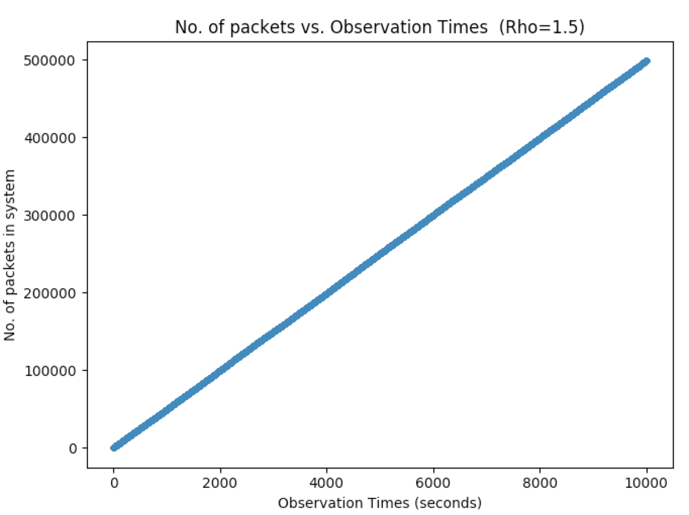

**Fig 9:** No. of packets vs. Observation times (Rho=1.5) **Fig 10:** No. of packets vs. Observation times (Rho=0.5)

The queue M/M/1 was also simulated at ρ = 0.5, and number of packets in the system as seen by observation events were plotted against observation times to analyze any differences in the trend. Figure 9 shows that at ρ = 1.5, number of packets in the system increase linearly with time, whereas in figure 10 at ρ = 0.5, the number of packets in the system fluctuated from 0 to 14, with average being at 1. This is because for ρ = 1.5, the utilization factor has surpassed 1, that is the arrival rate is greater in proportion than the service rate, so it does not matter which type of process the packets are coming with, as there is always an overload in the system so the number of packets in the system keep increasing with time.

# Question 5 – M/M/1 and D/M/1 – Comparison of E[N] and Ea[N]

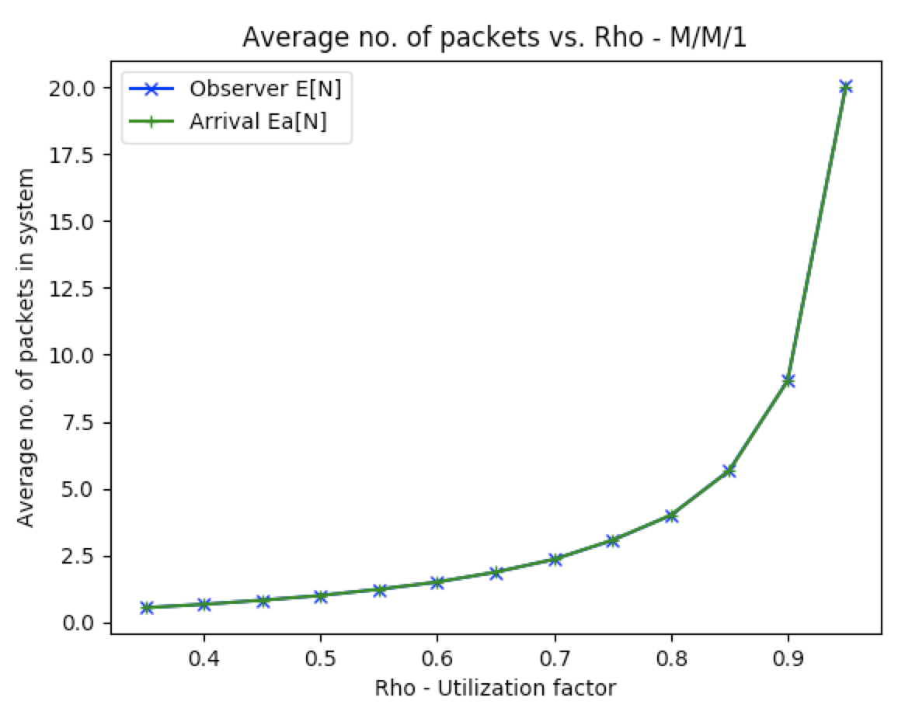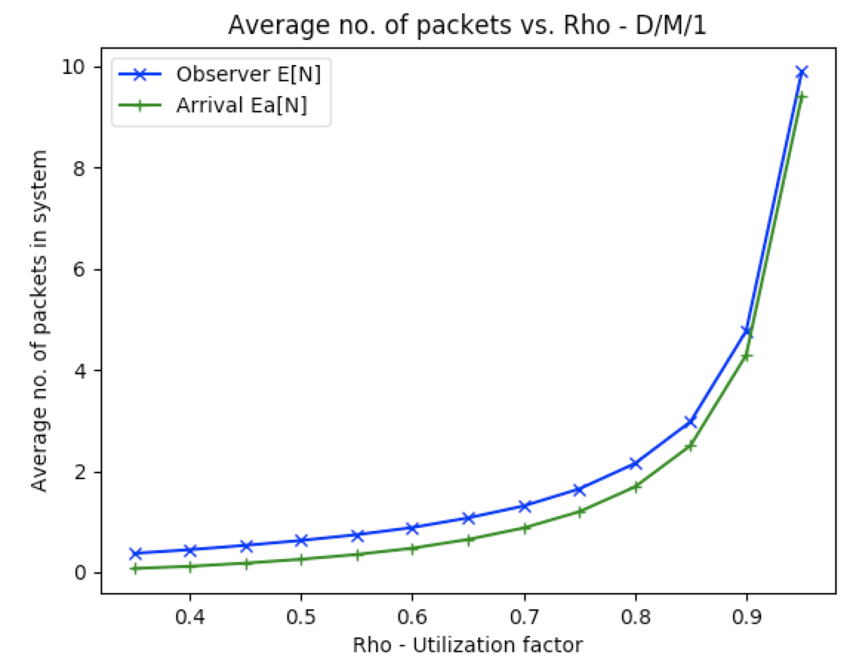

**Fig 11:** Comparison of E[N] and Ea[N] (M/M/1) **Fig 12:** Comparison of E[N] and Ea[N] (D/M/1)

Figures 11 and 12 above show the comparison of E[N] and Ea[N] for M/M/1 and D/M/1. As seen in figure 11, the average number of packets in the system seen by the observation event and the arrival event are the exact same for M/M/1. This is because the arrival process in M/M/1 is Poisson, hence it has the PASTA property (Poisson Arrivals See Time Averages). Figure 12 on the other hand, shows that the average number of packets seen by the observation event is a little bit higher than the average number of packets seen by the arrival event for D/M/1. This is because for D/M/1, the PASTA property does not hold true, and the arrival event sees a biased (non-representative) version of the state of system.

# Question 6 – M/M/1, D/M/1, and M/G/1 – Comparison of E[T]

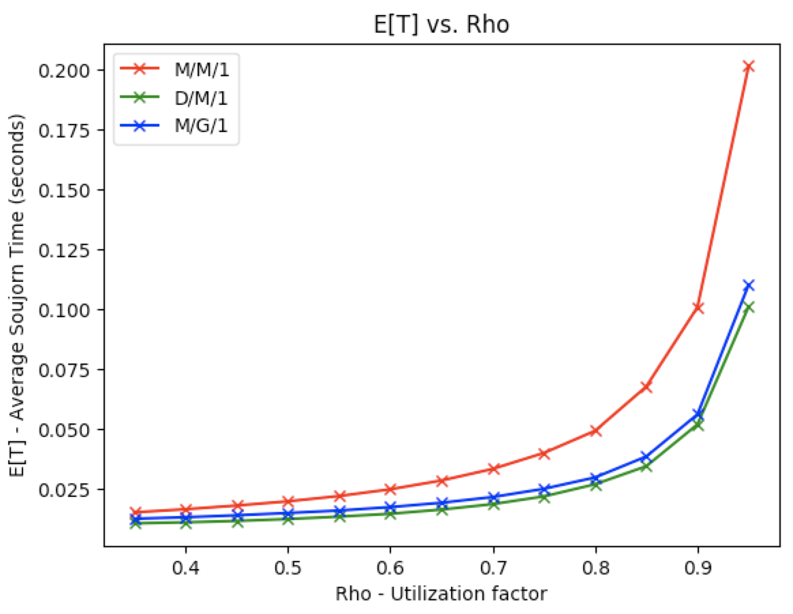

**Fig 13:** E[T] vs. Rho for M/M/1, D/M/1, and M/G/1

Figure 13 shows that the average sojourn time of a packet, that is, the total time taken by a packet in the system with respect to ρ for M/M/1, D/M/1, and M/G/1. As shown in the figure, the average sojourn time increases exponentially with respect to ρ for all three queues. It should be noted that the trend for these queues is very similar to the trends in figure 4 for E[N] vs. ρ, which makes sense because the number of packets in the system is directly related to the wait time for each packet, and wait time for each packet is a component of its sojourn time. Therefore, as the number of packets in the system increase, the average sojourn time for the packets also increase proportionally.

Once again, as seen in figure 4 earlier, the average sojourn time for packets in M/M/1 is higher than the packets in D/M/1 and M/G/1. This is because M/M/1 has an exponential arrival process, which means there is a chance of lots of packets coming in quickly and building up in the queue, hence having a greater delay.

# Question 7 – Simulator for M/D/1/K Queue

To add the functionality of a finite M/D/1/K queue in the class Simulation, the create_event_scheduler() function was modified such that every time a packet is generated, it is checked whether the buffer was full or not before proceeding further with that packet.

*Variables used:*



*Code Changed in create_event_scheduler() function:*

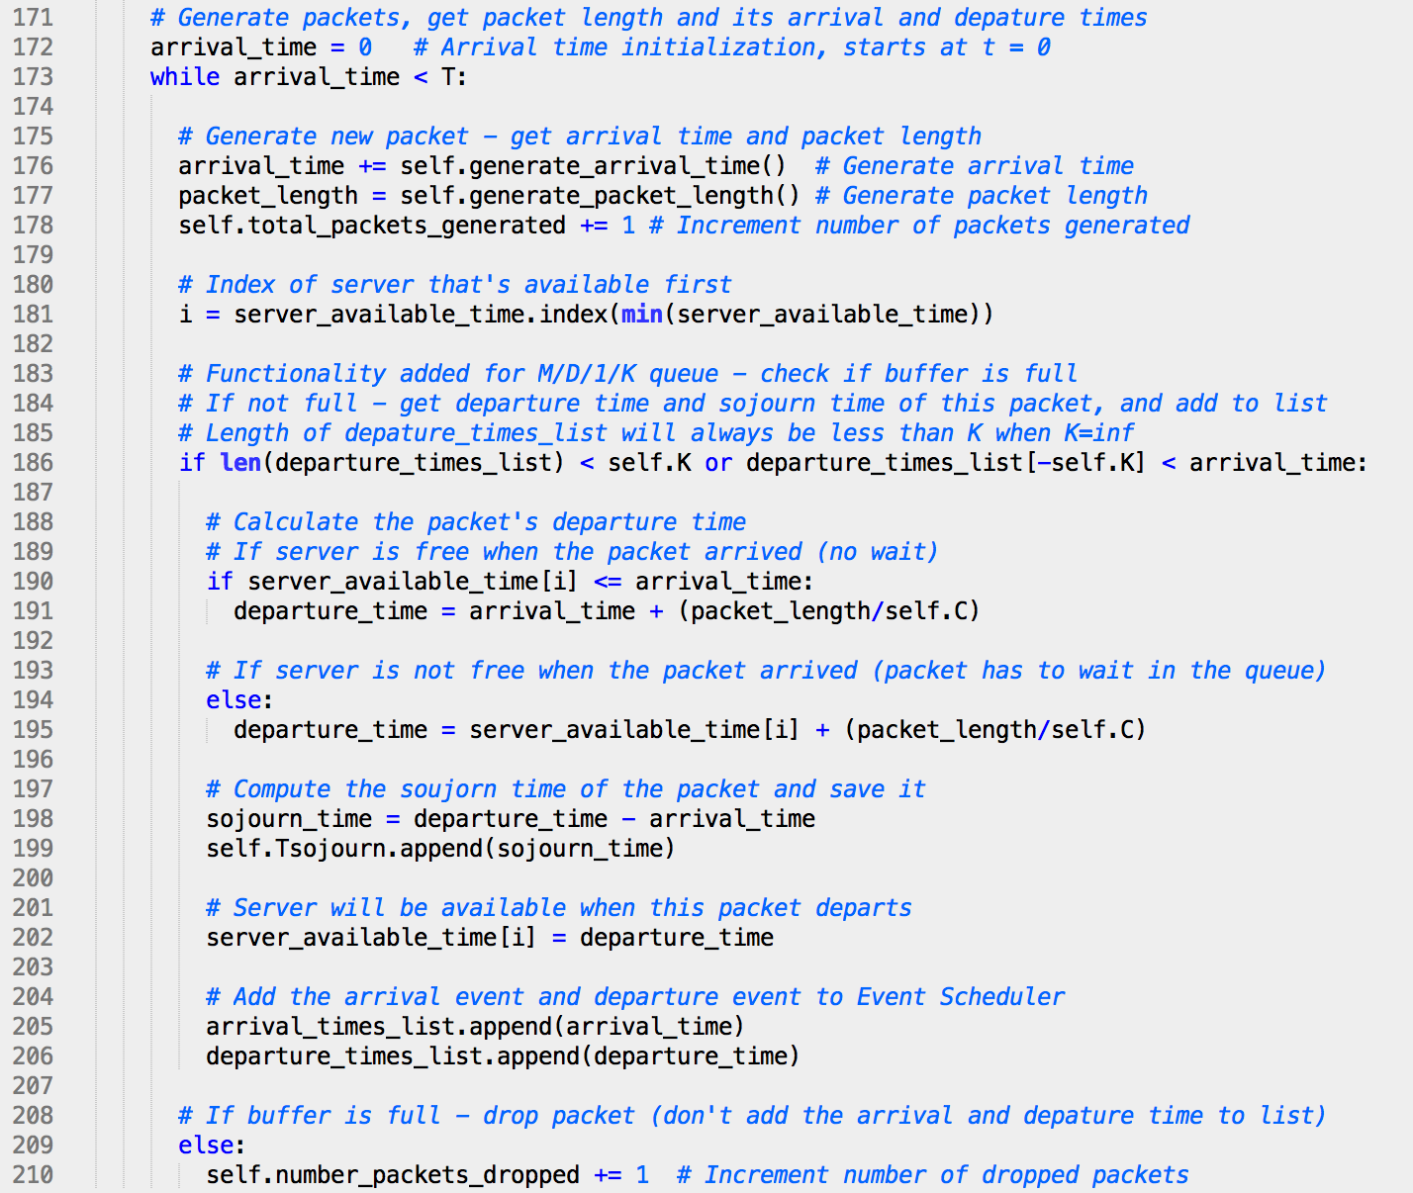

The chunk of code in lines 183 to 201 in Question 2 was put in an if-else condition in the code above in lines 186 and 209. After a packet was generated with its arrival time and packet length, it was checked whether the buffer is full or not. If the buffer is not full, the rest of code is executed where the packet’s departure time and sojourn time are computed, and the events are added to the arrival_times_list and departure_times_list. However, if the buffer is found to be full, then the packet is dropped, that is, ignored and not added to the arrival_times_list and departure_times_list, and the number_packets_dropped variable was incremented by 1.

The condition to check if the buffer has space is done by checking two conditions. First is if the number of departure events (same as the length of the departure_times_list) is less than the buffer size. For K = inf (for M/M/1, D/M/1, M/G/1 etc), this condition will always hold true as the number of departure events in the system will always be less than infinity. For the M/D/1/K case, it will still hold true for the first number of K-1 events. If the first condition is not true (that is, K is finite, and the number of departure events so far is more than the buffer size K), it checks for the second if condition, where it looks for the last Kth packet, and checks for its departure time. If that is going to leave before this new packet’s arrival time, it would mean the buffer has space to serve this new packet. If this condition fails, it means the buffer is full.

The rest of the functionality in create_event_scheduler() of creating observation events, and adding all observation, arrival, and departure events sorted with time to the Event_Scheduler remains the same as before.

The variables utilized here are number_packets_dropped and total_packets_generated, as PLOSS for M/D/1/K is computed as the number of packets dropped by the system divided by the total number of packets generated.

# Question 8 – M/D/1/K– PLOSS (0.4 ≤ ρ ≤ 3)

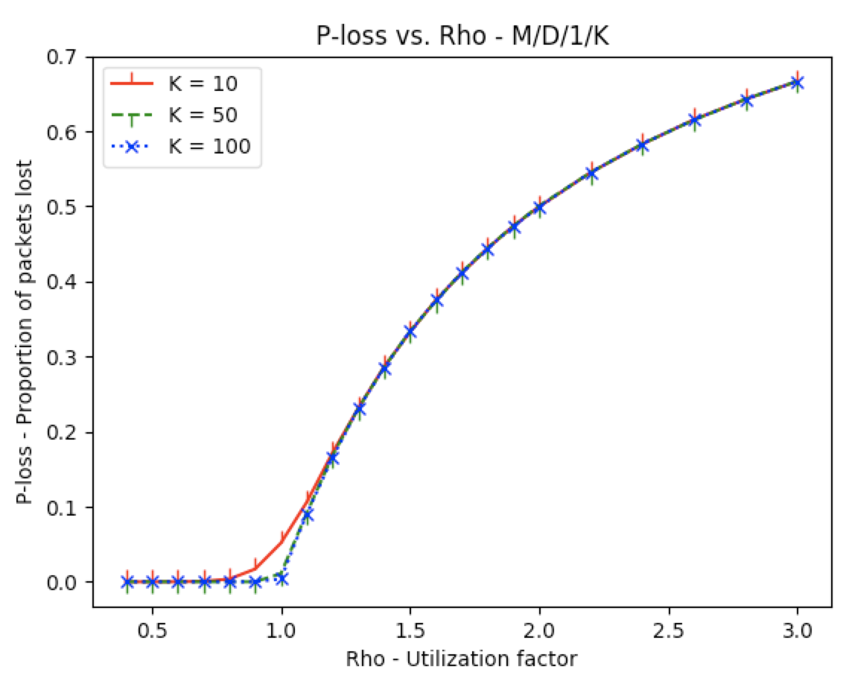

**Fig 14:** PLOSS vs. Rho for M/D/1/K when K=10, 50, and 100

Figure 14 shows the relationship between PLOSS and ρ for M/D/1/K. As seen, PLOSS is 0 until ρ=0.7 for all three of these queues. From ρ=0.7 to ρ=1.2, the three queues have a slightly different PLOSS. For the queue with K=10, PLOSS increases more rapidly than the queue with K=50 and 100. However, after ρ=1.2, all three of these queues had the same PLOSS, and had a logarithmic relationship between PLOSS and ρ. This is because a utilization factor greater than 1 means higher arrival rate than service rate. Once the utilization factor of the queue has surpassed a certain threshold, the size of the buffer becomes irrelevant as the buffer keeps getting utilized at the same rate, so PLOSS depends more on the utilization factor at that point than the size of the buffer, and increases logarithmically.

It should be noted that when the PLOSS value is different for the queues from ρ=0.7 to ρ=1.2, it is higher when K=10 and the buffer size is smaller, compared to when K=100 and buffer size is bigger, which is as expected. Interestingly however, from ρ=0.7 to ρ=1.2, PLOSS value is the same for both K=50 and K=100. This is because the size of the buffer only matters until a certain point, and then the buffer keeps getting fuller and serviced similarly for both these queues.

# Question 9 – M/D/2 and M/D/1 (rate 2C) – E[N] (0.35 ≤ ρ ≤ 0.95)

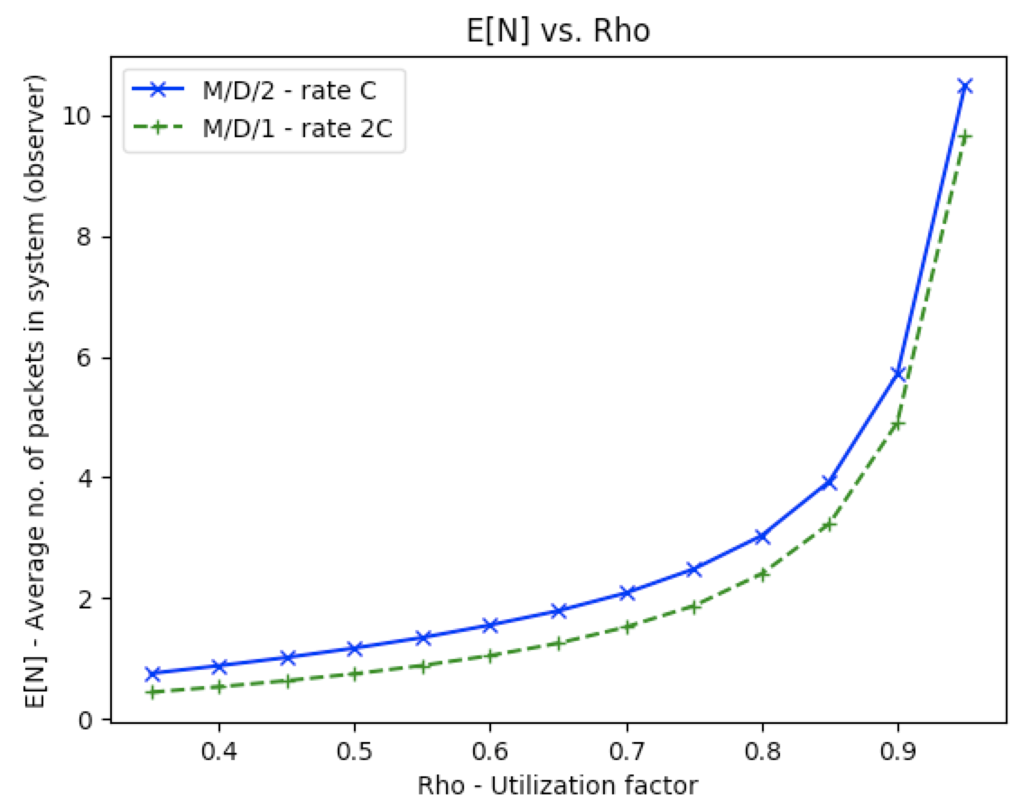

**Fig 15:** E[N] vs. Rho for M/D/2 and M/D/1

Figure 15 shows a comparison of the average number of packets in the system in M/D/2 with transmission rate of C, and M/D/1 with transmission rate of 2C. As shown, M/D/1 is a better system as it has less average number of packets in the system at each ρ, so has lesser delay. This is because for both these queues, the arrival rate λ remains the same but for M/D/1 the service time is faster. Arrival rate is calculated as $λ= { nC}/L$, so for M/D/1, it has 2C, whereas for M/D/2, n=2, which in turn makes it equal for both as the other parameters are the same. However, the transmission time for each packet is still L/C regardless of how many servers are available in the system. Therefore, since C increased to 2C in M/D/1, it meant having a lesser delay, which in turn meant lower average number of packets in the system.

It should be noted that despite M/D/1 giving a better result, realistically, M/D/2 may be a better choice as it has system reliability. If one server fails by any chance, another can continue transmitting packets in the system.